Setting up the Public IP address for Jenkins Service

Home Router configuration: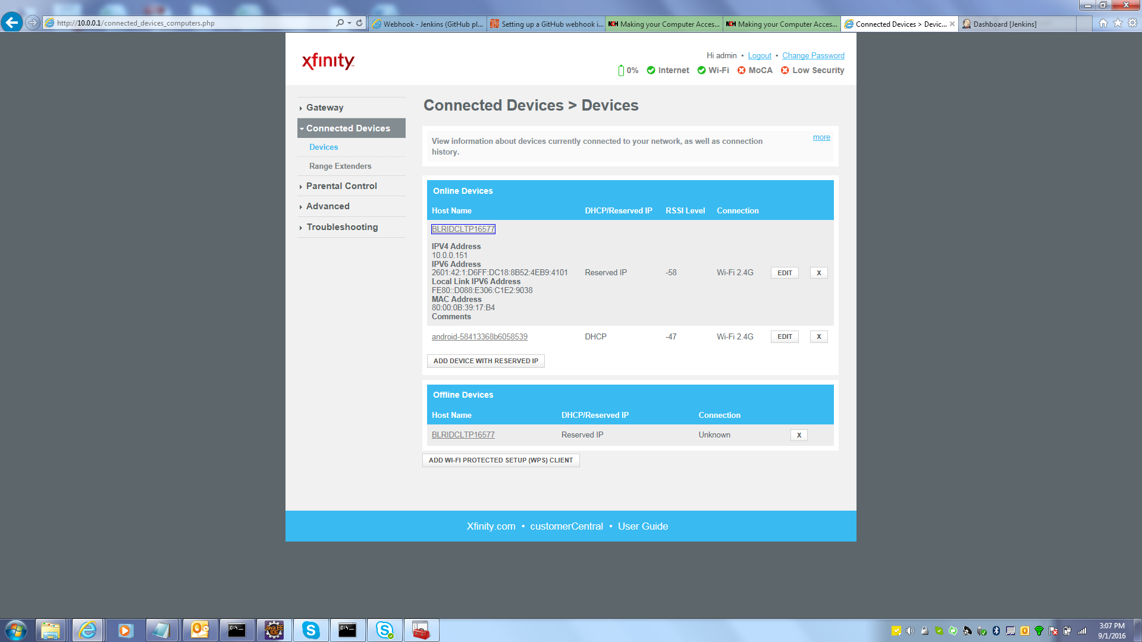

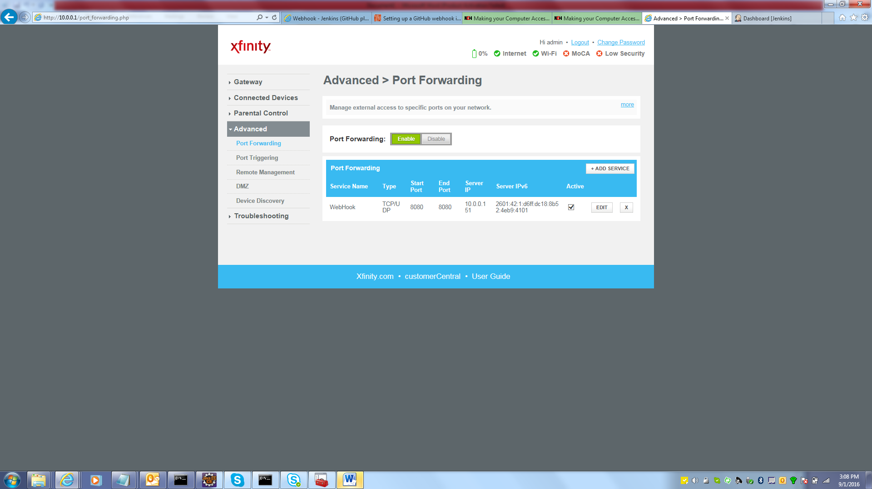

Git Hub repository Configuration:

Setup the Jenkins Github webhook: - use the IP of the router and not the ip of the jenkin server. The router ip will receive the webhook even and will forward this to Jenkins server.

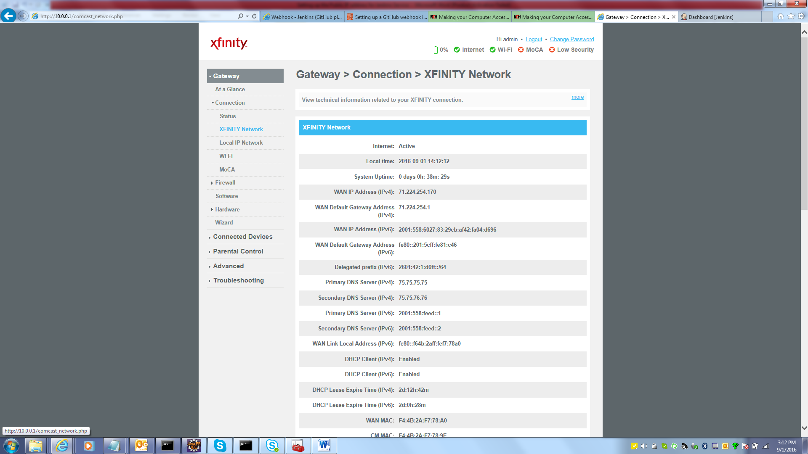

In GitHub go to Repository🡪Settings🡪WebHook&Services

Go to Services🡪Add Service serach for Jenkins (GitHub Plugin)

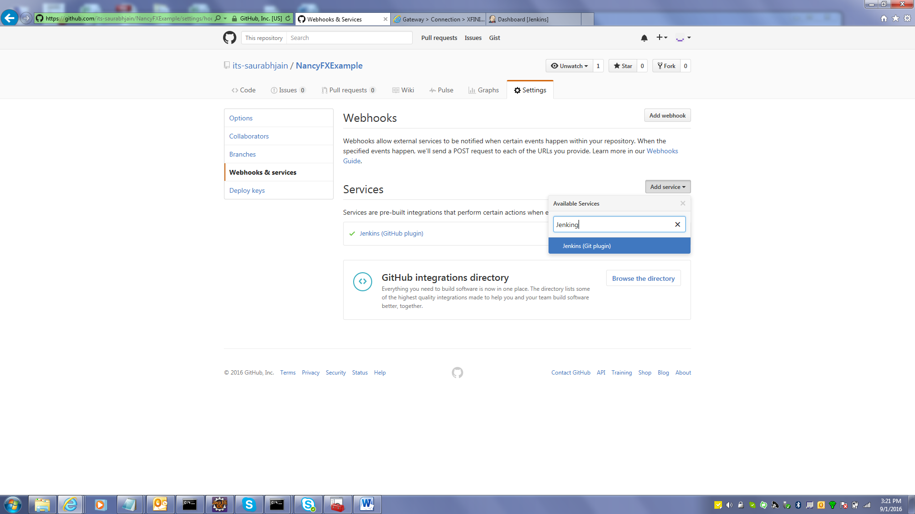

Enter webhook url

